Developer Tool Tasks

1. Remove Border Radius and make it a rectangular button for all the 4 items in the top Right Nav Bar



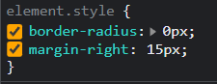 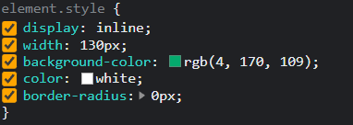

2. Change the color and increase the size of “**Home Icon**” in the top left corner to 30px and green color

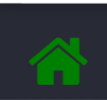 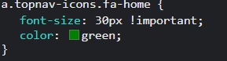

3. Change the words React Quiz to “Java Quiz”

 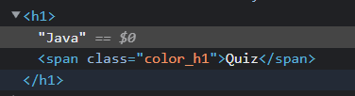

4. Change the background color of Top Nav bar to Orange.



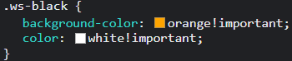

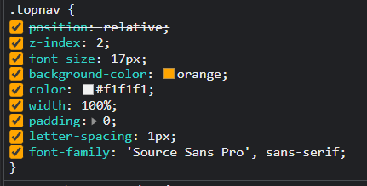

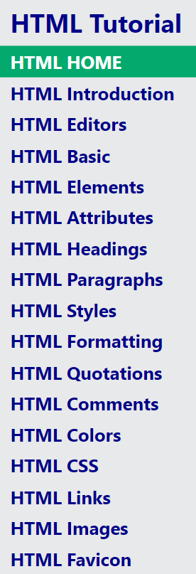5. Change the font color of sidebar to coral and change to font-weight to bold

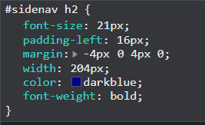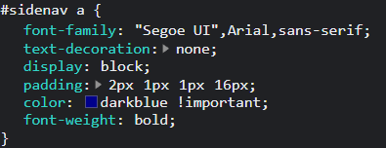

6. Try different Border styles (Solid, Dashed, dotted, double, groove, inset, outset, Ridge) to color picker.

Solid:

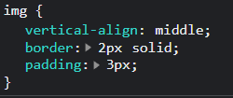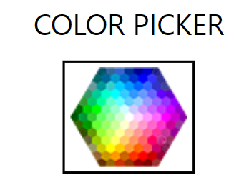

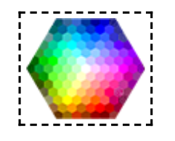Dashed:

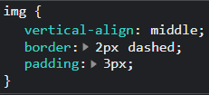

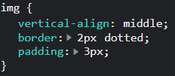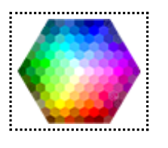Dotted:

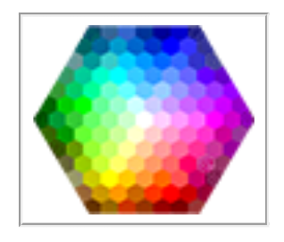Groove:

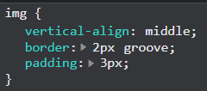

Inset:

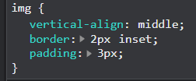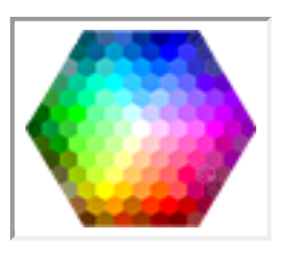

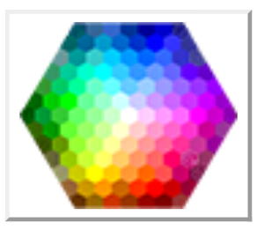Outset:

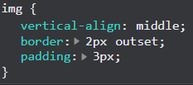

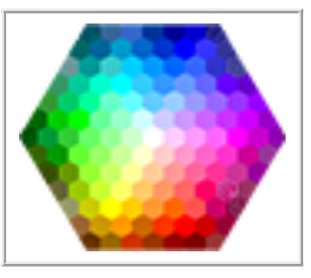Ridge:

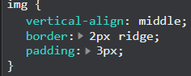

7. Change the Previous and Next button to Oval Shape.



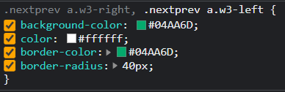

8. Change w3 school image to black

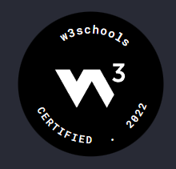

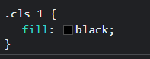

9. When Links like “Tutorial, Reference, Exercise, Videos” are clicked, the dropdown is now opening with a width of 100%. Try making it to 50%. And change background color to rgb(0, 150, 0)

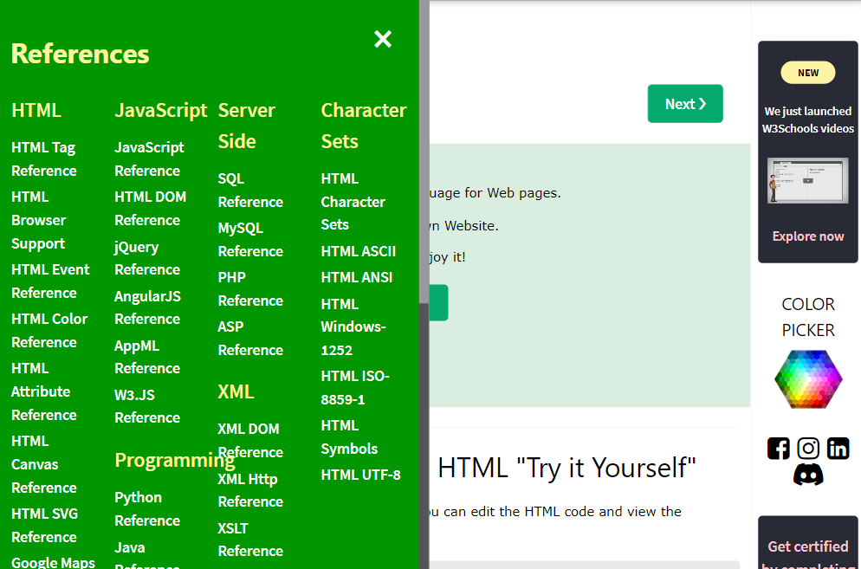

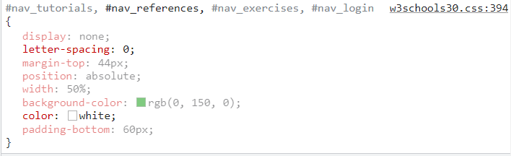

10. Remove the Scrolling option in sidebar by deactivating Overflow option